

DEPARTMENT OF INFORMATION TECHNOLOGY

IT3811-PROJECT WORK (Review – 1 – Project Plan)

Name (s) : Poovarasan M , Saravanan C , Surya P ,Surya S

Date :

Project Title : Braistrop – advanced deep learning model to predict the brain stroke

Problem Statement:

* Stroke is a leading cause of death and disability worldwide.
* Early detection and diagnosis play a crucial role in reducing its impact.
* Traditional methods rely heavily on manual interpretation of CT scans, which can be time-consuming and prone to human error.

Comparison with the Existing Systems:

* In the existing system is mostly developed by using textual data .
* Few projects are focused to predicting the brain stroke through MRI or CT scan.
* They were used few deep learning models such as Convolutional neural network (CNN), Long short –term memory(LSTM) and Bidirectional Long short-term memory(BiLSTM).
* These model are used to predict the stroke with decent accuracy and precision.

Proposed System:

* We are proposing model to increase the accuracy by using efficient Deep learning model.
* Train the model with large dataset
* Deploy the user interface.

System Architecture (To be enclosed as a separate sheet):

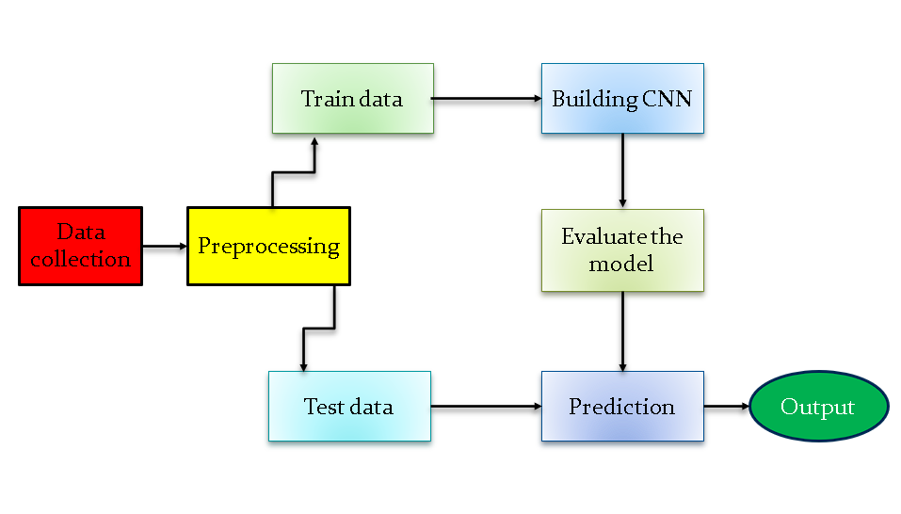

Technology Stack:

* Artificial Intelligence,
* Machine Learning
* and deep learning
* Medical Image Processing

Expected Outcome:

The accuracy will be 95% to 98%

Comments/Suggestions by Guide:

Comments/Suggestions by Project-Co-Ordinator:

Signature[Students] Signature[Guide] Signature[Project Co-Ordinator]